**DAILY ONLINE ACTIVITIES SUMMARY**

|  |  |  |  |  |  |  |  |  |
| --- | --- | --- | --- | --- | --- | --- | --- | --- |
| **Date:** | **26/05/2020** | | | | | **Name:** | **SHONE K SUNNY** | |
| **Sem & Sec** | **8th sem,A** | | | | | **USN:** | **4AL14CS081** | |
| **Online Test Summary** | | | | | | | | |
| **Subject** | | **BDA** | | | | | | |
| **Max. Marks** | | **40** | | **Score** | | | **36** | |
| **Certification Course Summary** | | | | | | | | |
| **Course** | **Getting Started To Hadoop** | | | | | | | |
| **Certificate Provider** | | | **GreatLearning** | | **Duration** | | | **20mins** |
| **Coding Challenges** | | | | | | | | |
| **Problem Statement:**[**Write a program in C to print all permutations of a given string using pointers**](https://github.com/orgs/alvas-education-foundation/teams/final-year-2019-20-batch/discussions/287)**.** | | | | | | | | |
| **Status: Solved** | | | | | | | | |
| **Uploaded the report in Github** | | | | | **Yes** | | | |
| **If yes Repository name** | | | | | **shonekks** | | | |
| **Uploaded the report in slack** | | | | | **Yes** | | | |

Online Test Details: (Attach the snapshot and briefly write the report for the same)

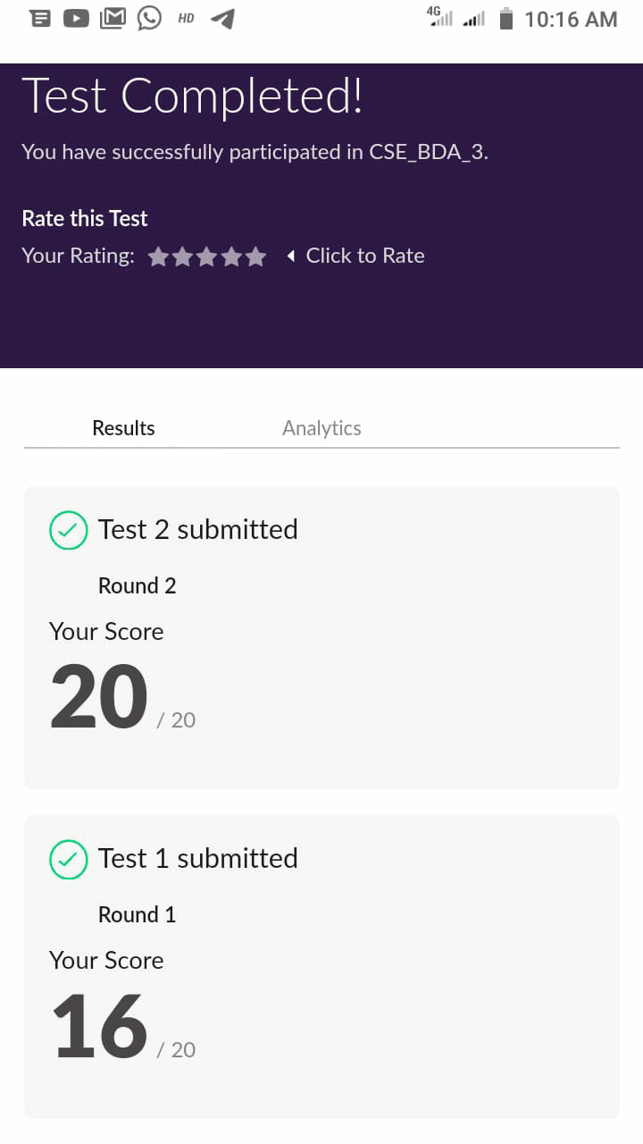

Certification Course Details: (Attach the snapshot and briefly write the report for the same)

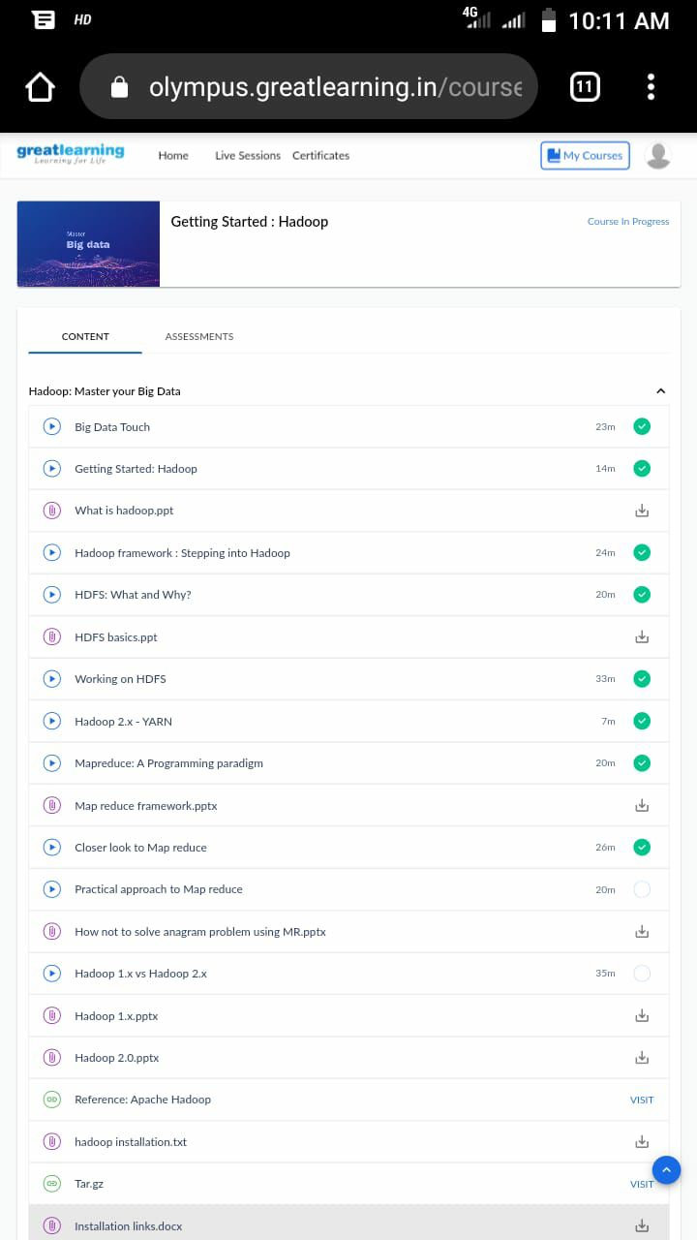

MAP REDUCE:-

Hadoop MapReduce is a programming paradigm at the heart of Apache Hadoop for providing massive scalability across hundreds or thousands of Hadoop clusters on commodity hardware. The MapReduce model processes large unstructured data sets with a distributed algorithm on a Hadoop cluster.Map job scales takes data sets as input and processes them to produce key value pairs. Reduce job takes the output of the Map job.The execution flow occurs as follows:

* Input data is split into small subsets of data.
* Map tasks work on these data splits.
* The intermediate input data from Map tasks is then submitted to Reduce task after an intermediate process called shuffle.
* The Reduce task(s) works on this intermediate data to generate the result of a MapReduce Job.

Coding Challenges Details: (Attach the snapshot and briefly write the report for the same)

**PROGRAM 1**

/* [Write a program in C to print all permutations of a given string using pointers](https://github.com/orgs/alvas-education-foundation/teams/final-year-2019-20-batch/discussions/287)*/

#include <stdio.h>  
#include <string.h>

/* Function to swap values at two pointers */  
void swap (char *x, char *y)  
{  
char temp;  
temp = *x;  
*x = *y;  
y = temp;  
}  
/ End of swap() */

/* Function to print permutations of string */  
void permute(char *a, int i, int n)  
{  
int j;  
if (i == n)  
printf("%s\n", a);  
else {  
for (j = i; j <= n; j++)  
{  
swap((a + i), (a + j));  
permute(a, i + 1, n);  
swap((a + i), (a + j)); //backtrack  
}  
}  
}

/* The main() begins */  
int main()  
{  
char a[20];  
int n;  
printf("Enter a string: ");  
scanf("%s", a);  
n = strlen(a);  
printf("Permutaions:\n");  
permute(a, 0, n - 1);  
getchar();  
return 0;  
}